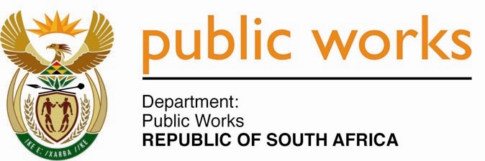

**MINISTRY**

**PUBLIC WORKS AND INFRASTRUCTURE**

**REPUBLIC OF SOUTH AFRICA**

Department of Public Works l Central Government Offices l 256 Madiba Street l Pretoria l Contact: +27 (0)12 406 1627 l Fax: +27 (0)12 323 7573

Private Bag X9155 l CAPE TOWN, 8001 l RSA 4th Floor Parliament Building l 120 Plain Street l CAPE TOWN l Tel: +27 21 402 2219 Fax: +27 21 462 4592

[www.publicworks.gov.za](http://www.publicworks.gov.za)

**NATIONAL ASSEMBLY**

**WRITTEN REPLY**

**QUESTION NUMBER: 419 [NO.** **NW484E]**

**INTERNAL QUESTION PAPER NO.: 01 of 2022**

**DATE OF PUBLICATION: 25 FEBRUARY 2022**

**DATE OF REPLY: MARCH 2022**

**419. Mr. P A van Staden (FF Plus) asked the Minister of Public Works and Infrastructure:**

(1) (a) What total number of the 81 575 properties that are under the custodianship of her department are in arrears with its property tax, (b) what total amount is in arrears and (c) to which municipalities are the arrear amounts due;

(2) whether she will make a statement on the matter? **NW484E**

**_______________________________________________________________________________**

**REPLY:**

**The Minister of Public Works and Infrastructure**

1. From the outset, DPWI would like to advise that there is no one-on-one relationship between the number of properties and the number of property rates accounts. This is due to a number of factors including:
   1. the issue that municipalities issue statements based on the erf number which could include multiple buildings
   2. the building on our asset register could be an SDF (State Domestic Facility)

As at 31st January 2022, as per the age analysis submitted by municipalities to DWPI, there were 145 municipalities with 10 483 total number of accounts with arrear balances. The total outstanding arrears amount on property rates as per age analysis from municipalities was R611 million. The breakdown on the number and amount outstanding on property rates is as follows:

|  |  |  |  |
| --- | --- | --- | --- |
| **As at 31 January 2022** | | | |
| **Name of Region/Province** | **Number of Municipality** | **Sum of Number of Accounts** | **Sum of Outstanding Amount: Property Rates** |
| Bloemfontein | 18 | 1 206 | R 16 342 786.38 |
| Cape Town | 24 | 2 237 | R 274 320 970.32 |
| Durban | 35 | 1 377 | R 108 716 589.05 |
| Gqeberha/PE | 10 | 505 | R 4 928 936.85 |
| Johannesburg | 8 | 2 349 | R 67 399 359.40 |
| Kimberley | 16 | 1 255 | R 5 893 086.00 |
| Mmabatho | 9 | 305 | R 35 005 763.20 |
| Polokwane | 19 | 705 | R 4 170 733.60 |
| Pretoria | 1 | 446 | R 70 182 174.00 |
| Umtata | 5 | 98 | R 24 387 804.00 |
| **Grand Total** | **145** | **10 483** | **R 611 348 202.80** |

1. Notwithstanding the above mentioned, DWPI has made payments across all 257 municipalities to the value of R1.8 billion broken as follows per region:

|  |  |
| --- | --- |
| **Sum of PAID AMOUNT: April 2021 - January 2022** | |
| **Name of Region/Province** | **Grand Total** |
| BLOEMFONTEIN | R 86 412 680.30 |
| CAPE TOWN | R 295 342 083.84 |
| DURBAN | R 249 967 618.62 |
| JOHANNESBURG | R 294 627 600.55 |
| KIMBERLEY | R 80 915 628.62 |
| MMABATHO | R 36 392 992.28 |
| NELSPRUIT | R 105 308 322.79 |
| POLOKWANE | R 50 751 651.03 |
| PORT ELIZABETH | R 177 238 766.23 |
| PRETORIA | R 416 871 112.81 |
| UMTATA | R 25 480 449.37 |
| **Grand Total** | **R 1 819 308 906.44** |
|  |  |

DPWI has further noted on the age analysis that the amount outstanding on property rates is as a result of various reasons amongst other being:

1. Claims or invoices not submitted despite request sent to municipalities by the department;
2. Non-allocation of payments by municipalities; or
3. Incorrect interest charged mainly due to non-allocation of payments made; or
4. Ingonyama Trust Board Properties not surveyed; or
5. Incorrect billing by municipalities due to unjustified increase in property market values.